ds-prod-tbru-ts-db-1 10.218.8.112 iLO:10.219.104.128
ds-prod-tbru-ts-db-2 10.218.8.113 iLO:10.219.104.142
m1-prod-tbru-ts-db-1 10.218.3.163 10.214.3.112 (vlan 1503) iLO:10.219.102.155

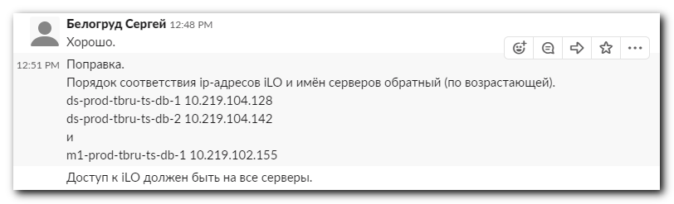
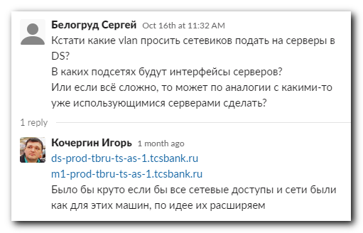

From: Belogrud Sergey Vladimirovich <s.belogrud@tinkoff.ru>
Sent: Thursday, October 17, 2019 12:14 PM
To: helpdesk_in <helpdesk_in@tinkoff.ru>
Cc: net-admins <net-admins@tinkoff.ru>
Subject: Настройка портов коммутаторов для серверов ds-prod-tbru-ts-db-1, ds-prod-tbru-ts-db-2

Добрый день.

Задача на net-admins.

Настройка портов коммутаторов для серверов ds-prod-tbru-ts-db-1, ds-prod-tbru-ts-db-2.
https://netbox.tcsbank.ru/dcim/devices/5009/
https://netbox.tcsbank.ru/dcim/devices/5008/

Настроить возможность использования на этих двух серверах vlan 1808.
Аналогично тому, как это уже сделано для сервера ds-prod-tbru-ts-as-1.

Оригинал исходной задачи: https://jira.tcsbank.ru/browse/ITP-2346 , https://jira.tcsbank.ru/browse/TS-1216 .

Для серверов планируется использовать ip-адреса: 10.218.8.112, 10.218.8.113.
Подтвердите, что эти адреса можно использовать для этих серверов. Или сообщите какие ip-адреса взять.

С уважением,

Сергей Белогруд
Старший системный администратор

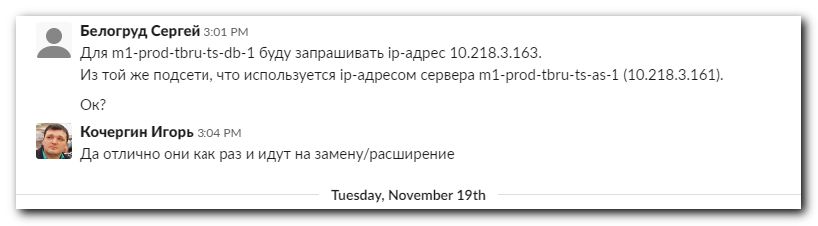

From: Belogrud Sergey Vladimirovich <s.belogrud@tinkoff.ru>
Sent: Monday, November 18, 2019 3:36 PM
To: helpdesk_in <helpdesk_in@tinkoff.ru>
Cc: net-admins <net-admins@tinkoff.ru>
Subject: Настройка портов коммутаторов для сервера m1-prod-tbru-ts-db-1

Добрый день.

Задача на net-admins.

Настройка портов коммутаторов для сервера m1-prod-tbru-ts-db-1.
https://netbox.tcsbank.ru/dcim/devices/4871/

Настроить возможность использования на этом сервере vlan 1803.
Аналогично тому, как это уже сделано для сервера m1-prod-tbru-ts-as-1.

Оригинал исходной задачи: https://jira.tcsbank.ru/browse/ITP-2346 , https://jira.tcsbank.ru/browse/TS-1216 .

Для сервера планируется использовать ip-адрес: 10.218.3.163.
Подтвердите, что этот адрес можно использовать для этого сервера. Или сообщите какой ip-адреса взять.

С уважением,

Сергей Белогруд
Старший системный администратор

#
# I’ve used follow command to get names of network interfaces.
#
root@ds-prod-tbru-ts-db-1:~# ifconfig -a

#
# Here is a way how to up network interface.
#
root@ds-prod-tbru-ts-db-1:~# ip link set dev eno5 up
root@ds-prod-tbru-ts-db-1:~# ip link set dev eno6 up

#
# Here I see, that “Seed” become available. This means this network interface linked to network switch.
# But eno6 have “Unknown” speed. It looks like this network interface is not linked to the network switch correctly.
#
root@ds-prod-tbru-ts-db-1:~# ethtool eno5
Settings for eno5:
Supported ports: [ FIBRE ]
Supported link modes: 1000baseKX/Full
10000baseKR/Full
25000baseCR/Full
25000baseKR/Full
25000baseSR/Full
Supported pause frame use: Symmetric
Supports auto-negotiation: Yes
Supported FEC modes: Not reported
Advertised link modes: 1000baseKX/Full
10000baseKR/Full
25000baseCR/Full
25000baseKR/Full
25000baseSR/Full
Advertised pause frame use: Symmetric
Advertised auto-negotiation: Yes
Advertised FEC modes: Not reported
Speed: 25000Mb/s
Duplex: Full
Port: FIBRE
PHYAD: 0
Transceiver: internal
Auto-negotiation: on
Supports Wake-on: g
Wake-on: g
Current message level: 0x00000004 (4)
link
Link detected: yes
root@ds-prod-tbru-ts-db-1:~#

root@ds-prod-tbru-ts-db-1:~# ethtool eno6
Settings for eno6:
Supported ports: [ FIBRE ]
Supported link modes: 1000baseKX/Full
10000baseKR/Full
25000baseCR/Full
25000baseKR/Full
25000baseSR/Full
Supported pause frame use: Symmetric
Supports auto-negotiation: Yes
Supported FEC modes: Not reported
Advertised link modes: 1000baseKX/Full
10000baseKR/Full
25000baseCR/Full
25000baseKR/Full
25000baseSR/Full
Advertised pause frame use: Symmetric
Advertised auto-negotiation: Yes
Advertised FEC modes: Not reported
Speed: Unknown!
Duplex: Unknown! (255)
Port: FIBRE
PHYAD: 0
Transceiver: internal
Auto-negotiation: on
Supports Wake-on: g
Wake-on: d
Current message level: 0x00000004 (4)
link
Link detected: no
root@ds-prod-tbru-ts-db-1:~#

#
# Here I confirm, that only one network interface linked to network switch correctly.
#
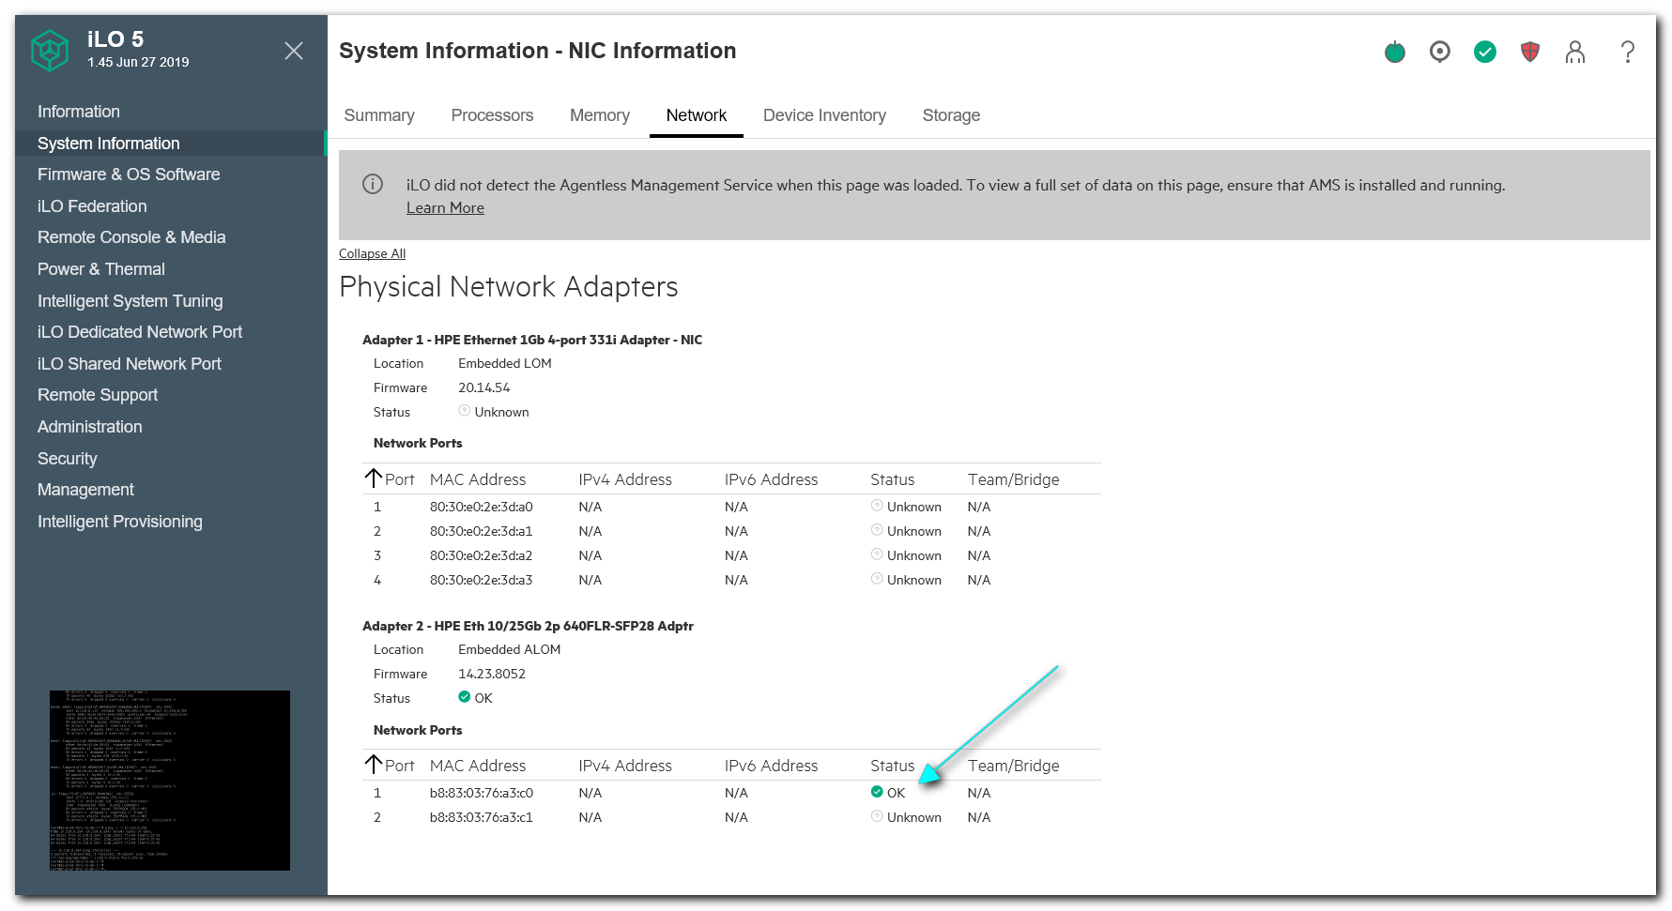

#
# To compare, for example, on the second server both network interfaces linked to the network switch correctly.
#
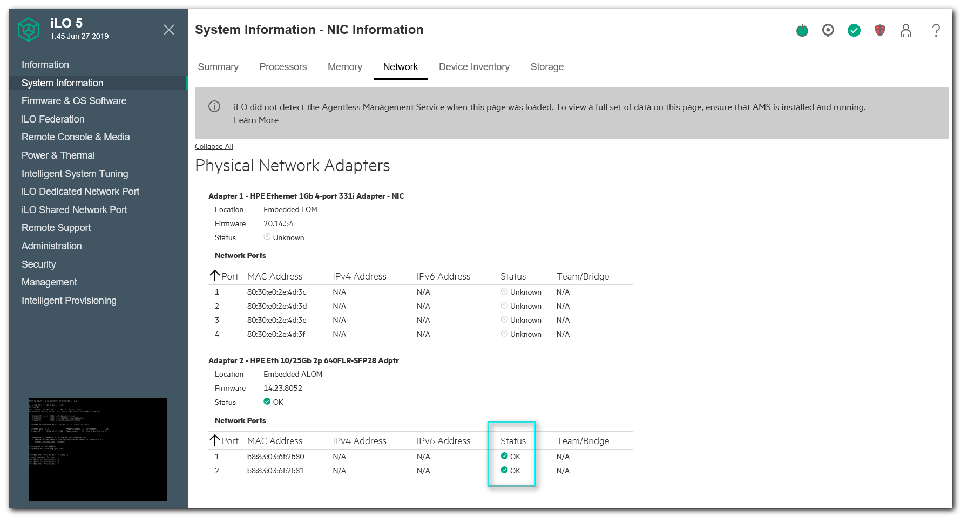

#
# As a template was taken follow config.
#
root@ds-prod-tbru-ts-as-1:~# cat /etc/network/interfaces
# This file describes the network interfaces available on your system
# and how to activate them. For more information, see interfaces(5).

source /etc/network/interfaces.d/*

# The loopback network interface
auto lo
iface lo inet loopback

# The primary network interface
# auto eno5
# iface eno5 inet dhcp
auto eno5
iface eno5 inet manual
bond-master bond0

auto eno6
iface eno6 inet manual
bond-master bond0

auto bond0
iface bond0 inet manual
bond-mode 4
bond-miimon 100
bond-lacp-rate 1
bond-slaves eno5 eno6

auto bond0.1808
iface bond0.1808 inet static
address 10.218.8.163
netmask 255.255.255.0
gateway 10.218.8.254

dns-search tcsbank.ru
root@ds-prod-tbru-ts-as-1:~#

https://linuxconfig.org/how-to-restart-network-on-ubuntu-18-04-bionic-beaver-linux
https://www.ostechnix.com/how-to-configure-ip-address-in-ubuntu-18-04-lts/
http://blog.sedicomm.com/2018/05/25/kak-nastroit-staticheskij-ip-adres-v-ubuntu-18-04/

https://askubuntu.com/questions/1112288/netplan-configuring-2-vlan-on-same-bonding
https://habr.com/ru/post/448400/
https://netplan.io/examples
https://www.snel.com/support/how-to-set-up-lacp-bonding-on-ubuntu-18-04-with-netplan/

[s.belogrud@TCS4357]# ssh user@10.218.8.112
Warning: Permanently added '10.218.8.112' (RSA) to the list of known hosts.
user@10.218.8.112's password:
Welcome to Ubuntu 18.04.3 LTS (GNU/Linux 4.15.0-55-generic x86_64)

* Documentation: https://help.ubuntu.com
* Management: https://landscape.canonical.com
* Support: https://ubuntu.com/advantage

System information as of Thu Nov 21 14:42:53 UTC 2019

System load: 0.02 Memory usage: 0% Processes: 765
Usage of /: 15.0% of 63.96GB Swap usage: 0% Users logged in: 1

* Canonical Livepatch is available for installation.
- Reduce system reboots and improve kernel security. Activate at:
https://ubuntu.com/livepatch

0 packages can be updated.
0 updates are security updates.

Last login: Tue Nov 19 11:45:48 2019
user@ds-prod-tbru-ts-db-1:~$ sudo -i
[sudo] password for user:
root@ds-prod-tbru-ts-db-1:~#

#
# Here is preset for vim
# :set tabstop=4 shiftwidth=4 expandtab
# :retab

root@ds-prod-tbru-ts-db-1:~# cat /etc/netplan/50-cloud-init.yaml
# This file is generated from information provided by
# the datasource. Changes to it will not persist across an instance.
# To disable cloud-init's network configuration capabilities, write a file
# /etc/cloud/cloud.cfg.d/99-disable-network-config.cfg with the following:
# network: {config: disabled}
network:
version: 2
renderer: networkd
ethernets:
eno5:
dhcp4: no
eno6:
dhcp4: no
bonds:
bond0:
dhcp4: no
dhcp6: false
interfaces: [eno5, eno6]
parameters:
mode: 802.3ad
mii-monitor-interval: 100
lacp-rate: fast
vlans:
bond0.1808:
id: 1808
link: bond0
dhcp4: no
addresses: [10.218.8.112/24]
gateway4: 10.218.8.254
nameservers:
search: [tcsbank.ru]
addresses: [10.219.50.4, 10.219.50.5]

root@ds-prod-tbru-ts-db-1:~#

#
# Here is how to apply this config and up made by it network.
#
root@ds-prod-tbru-ts-db-1:~# netplan apply

[support@centos puppet]$ pass insert common/linux-other3
Enter password for common/linux-other3:
Retype password for common/linux-other3:
[support@centos puppet]$ pass
Password Store
└── common
├── linux-bsv
├── linux-default
├── linux
├── linux-other1
├── linux-other2
├── linux-other3
└── windows-current
[support@centos puppet]$

[support@centos puppet]$ ansible-playbook 20180808-1512.install.puppet-agent.yaml -i list_of_hosts --become --extra-vars "ansible_user=user ansible_password=$(pass common/linux-other3) ansible_sudo_pass=$(pass common/linux-other3) ansible_ssh_common_args='-oStrictHostKeyChecking=no -oPubkeyAuthentication=no'"

PLAY [all] ************************************************************************************************************************************************************************************************

TASK [Gathering Facts] ************************************************************************************************************************************************************************************
ok: [10.218.8.113]
ok: [10.218.8.112]

TASK [Add Puppetlabs Repo v5 (rpm) for RHEL] **************************************************************************************************************************************************************
skipping: [10.218.8.112]
skipping: [10.218.8.113]

TASK [Add Puppetlabs Repo v5 (deb)] ***********************************************************************************************************************************************************************
fatal: [10.218.8.113]: FAILED! => {"changed": false, "msg": "W:GPG error: http://repo-linux.tcsbank.ru/puppetlabs/apt bionic InRelease: The following signatures couldn't be verified because the public key is not available: NO_PUBKEY 7F438280EF8D349F, E:The repository 'http://repo-linux.tcsbank.ru/puppetlabs/apt bionic InRelease' is not signed."}
fatal: [10.218.8.112]: FAILED! => {"changed": false, "msg": "W:GPG error: http://repo-linux.tcsbank.ru/puppetlabs/apt bionic InRelease: The following signatures couldn't be verified because the public key is not available: NO_PUBKEY 7F438280EF8D349F, E:The repository 'http://repo-linux.tcsbank.ru/puppetlabs/apt bionic InRelease' is not signed."}

PLAY RECAP ************************************************************************************************************************************************************************************************
10.218.8.112 : ok=1 changed=0 unreachable=0 failed=1 skipped=1 rescued=0 ignored=0
10.218.8.113 : ok=1 changed=0 unreachable=0 failed=1 skipped=1 rescued=0 ignored=0

[support@centos puppet]$

root@ds-prod-tbru-ts-db-1:~# echo 'APT::Get::AllowUnauthenticated "true";' > /etc/apt/apt.conf.d/99to-install-from-http

[support@centos puppet]$ ansible-playbook 20180808-1512.install.puppet-agent.yaml -i list_of_hosts --become --extra-vars "ansible_user=user ansible_password=$(pass common/linux-other3) ansible_sudo_pass=$(pass common/linux-other3) ansible_ssh_common_args='-oStrictHostKeyChecking=no -oPubkeyAuthentication=no'"

PLAY [all] ************************************************************************************************************************************************************************************************

TASK [Gathering Facts] ************************************************************************************************************************************************************************************
ok: [10.218.8.113]
ok: [10.218.8.112]

TASK [Add Puppetlabs Repo v5 (rpm) for RHEL] **************************************************************************************************************************************************************
skipping: [10.218.8.112]
skipping: [10.218.8.113]

TASK [Add Puppetlabs Repo v5 (deb)] ***********************************************************************************************************************************************************************
ok: [10.218.8.113]
ok: [10.218.8.112]

TASK [Add Puppetlabs Repo key (deb)] **********************************************************************************************************************************************************************
changed: [10.218.8.113]
changed: [10.218.8.112]

TASK [Install puppet-agent via apt module on Ubuntu with option -y] ***************************************************************************************************************************************
[WARNING]: Could not find aptitude. Using apt-get instead

fatal: [10.218.8.113]: FAILED! => {"changed": false, "msg": "No package matching 'puppet-agent' is available"}
fatal: [10.218.8.112]: FAILED! => {"changed": false, "msg": "No package matching 'puppet-agent' is available"}

PLAY RECAP ************************************************************************************************************************************************************************************************
10.218.8.112 : ok=3 changed=1 unreachable=0 failed=1 skipped=1 rescued=0 ignored=0
10.218.8.113 : ok=3 changed=1 unreachable=0 failed=1 skipped=1 rescued=0 ignored=0

[support@centos puppet]$

root@ds-prod-tbru-ts-db-1:~# egrep -v -e "^#|^$" /etc/apt/sources.list
deb http://archive.ubuntu.com/ubuntu bionic main restricted
deb http://archive.ubuntu.com/ubuntu bionic-updates main restricted
deb http://archive.ubuntu.com/ubuntu bionic universe
deb http://archive.ubuntu.com/ubuntu bionic-updates universe
deb http://archive.ubuntu.com/ubuntu bionic multiverse
deb http://archive.ubuntu.com/ubuntu bionic-updates multiverse
deb http://archive.ubuntu.com/ubuntu bionic-backports main restricted universe multiverse
deb http://archive.ubuntu.com/ubuntu bionic-security main restricted
deb http://archive.ubuntu.com/ubuntu bionic-security universe
deb http://archive.ubuntu.com/ubuntu bionic-security multiverse
root@ds-prod-tbru-ts-db-1:~#

root@ds-prod-tbru-ts-db-1:~# vim /etc/apt/sources.list
:%s/http:\/\/archive.ubuntu.com/http:\/\/repo-linux.tcsbank.ru\/repository/gc

root@ds-prod-tbru-ts-db-1:~#

root@m1-prod-tbru-ts-tb-1:~# apt-get update
Get:1 http://repo-linux.tcsbank.ru/repository/ubuntu bionic InRelease [242 kB]
Get:2 http://repo-linux.tcsbank.ru/repository/ubuntu bionic-updates InRelease [88.7 kB]
...
Get:35 http://repo-linux.tcsbank.ru/puppetlabs/apt bionic/puppet5 amd64 Packages [28.3 kB]
Fetched 19.9 MB in 7s (2,959 kB/s)
Reading package lists... Done
root@m1-prod-tbru-ts-tb-1:~#

root@ds-prod-tbru-ts-db-1:~# cat /etc/apt/sources.list
deb http://repo-linux.tcsbank.ru/repository/ubuntu bionic main restricted
deb http://repo-linux.tcsbank.ru/repository/ubuntu bionic-updates main restricted
deb http://repo-linux.tcsbank.ru/repository/ubuntu bionic universe
deb http://repo-linux.tcsbank.ru/repository/ubuntu bionic-updates universe
deb http://repo-linux.tcsbank.ru/repository/ubuntu bionic multiverse
deb http://repo-linux.tcsbank.ru/repository/ubuntu bionic-updates multiverse
deb http://repo-linux.tcsbank.ru/repository/ubuntu bionic-backports main restricted universe multiverse
deb http://repo-linux.tcsbank.ru/repository/ubuntu bionic-security main restricted
deb http://repo-linux.tcsbank.ru/repository/ubuntu bionic-security universe
deb http://repo-linux.tcsbank.ru/repository/ubuntu bionic-security multiverse
root@ds-prod-tbru-ts-db-1:~#

[support@centos puppet]$ ansible-playbook 20180808-1512.install.puppet-agent.yaml -i list_of_hosts --become --extra-vars "ansible_user=user ansible_password=$(pass common/linux-other3) ansible_sudo_pass=$(pass common/linux-other3) ansible_ssh_common_args='-oStrictHostKeyChecking=no -oPubkeyAuthentication=no'"

PLAY [all] ************************************************************************************************************************************************************************************************

TASK [Gathering Facts] ************************************************************************************************************************************************************************************
ok: [10.214.3.112]

TASK [Add Puppetlabs Repo v5 (rpm) for RHEL] **************************************************************************************************************************************************************
skipping: [10.214.3.112]

TASK [Add Puppetlabs Repo v5 (deb)] ***********************************************************************************************************************************************************************
ok: [10.214.3.112]

TASK [Add Puppetlabs Repo key (deb)] **********************************************************************************************************************************************************************
ok: [10.214.3.112]

TASK [Install puppet-agent via apt module on Ubuntu with option -y] ***************************************************************************************************************************************
[WARNING]: Could not find aptitude. Using apt-get instead

changed: [10.214.3.112]

TASK [Install new puppet] *********************************************************************************************************************************************************************************
skipping: [10.214.3.112]

TASK [Set puppet server in config] ************************************************************************************************************************************************************************
changed: [10.214.3.112]

TASK [Enable agent (for ubuntu)] **************************************************************************************************************************************************************************
fatal: [10.214.3.112]: FAILED! => {"changed": true, "cmd": "puppet agent --enable", "delta": "0:00:00.001942", "end": "2019-11-27 16:06:21.988932", "msg": "non-zero return code", "rc": 127, "start": "2019-11-27 16:06:21.986990", "stderr": "/bin/sh: 1: puppet: not found", "stderr_lines": ["/bin/sh: 1: puppet: not found"], "stdout": "", "stdout_lines": []}
...ignoring

TASK [First run puppet] ***********************************************************************************************************************************************************************************
fatal: [10.214.3.112]: FAILED! => {"changed": false, "disabled": false, "error": true, "msg": "puppet did not run", "rc": 1, "stderr": "", "stderr_lines": [], "stdout": "Info: Creating a new SSL key for m1-prod-tbru-ts-tb-1.tcsbank.ru\nInfo: Caching certificate for ca\nInfo: csr_attributes file loading from /etc/puppetlabs/puppet/csr_attributes.yaml\nInfo: Creating a new SSL certificate request for m1-prod-tbru-ts-tb-1.tcsbank.ru\nInfo: Certificate Request fingerprint (SHA256): 3E:7B:F1:C2:D2:78:C8:6C:C4:59:4D:0C:14:4B:E2:35:19:34:FE:54:A6:CF:14:36:69:17:31:BE:ED:CD:42:6D\nInfo: Caching certificate for ca\nExiting; no certificate found and waitforcert is disabled\n", "stdout_lines": ["Info: Creating a new SSL key for m1-prod-tbru-ts-tb-1.tcsbank.ru", "Info: Caching certificate for ca", "Info: csr_attributes file loading from /etc/puppetlabs/puppet/csr_attributes.yaml", "Info: Creating a new SSL certificate request for m1-prod-tbru-ts-tb-1.tcsbank.ru", "Info: Certificate Request fingerprint (SHA256): 3E:7B:F1:C2:D2:78:C8:6C:C4:59:4D:0C:14:4B:E2:35:19:34:FE:54:A6:CF:14:36:69:17:31:BE:ED:CD:42:6D", "Info: Caching certificate for ca", "Exiting; no certificate found and waitforcert is disabled"]}
...ignoring

PLAY RECAP ************************************************************************************************************************************************************************************************
10.214.3.112 : ok=7 changed=3 unreachable=0 failed=0 skipped=2 rescued=0 ignored=2

[support@centos puppet]$

[root@vm-puppetmaster02p ~]# puppet cert sign m1-prod-tbru-ts-tb-1.tcsbank.ru
Signing Certificate Request for:
"m1-prod-tbru-ts-tb-1.tcsbank.ru" (SHA256) 3E:7B:F1:C2:D2:78:C8:6C:C4:59:4D:0C:14:4B:E2:35:19:34:FE:54:A6:CF:14:36:69:17:31:BE:ED:CD:42:6D
Notice: Signed certificate request for m1-prod-tbru-ts-tb-1.tcsbank.ru
Notice: Removing file Puppet::SSL::CertificateRequest m1-prod-tbru-ts-tb-1.tcsbank.ru at '/etc/puppetlabs/puppet/ssl/ca/requests/m1-prod-tbru-ts-tb-1.tcsbank.ru.pem'
[root@vm-puppetmaster02p ~]#

#
# On Ubuntu 18.04.
# To get availability to use ifup and ifdown commands - need to install package “ifupdown”.
#
root@m1-prod-tbru-ts-db-1:~# apt-get install ifupdown
Reading package lists... Done
Building dependency tree
Reading state information... Done
Suggested packages:
ppp rdnssd
The following NEW packages will be installed:
ifupdown
0 upgraded, 1 newly installed, 0 to remove and 50 not upgraded.
Need to get 55.9 kB of archives.
After this operation, 227 kB of additional disk space will be used.
Get:1 http://repo-linux.tcsbank.ru/repository/ubuntu bionic-updates/main amd64 ifupdown amd64 0.8.17ubuntu1.1 [55.9 kB]
Fetched 55.9 kB in 1s (66.5 kB/s)
Selecting previously unselected package ifupdown.
(Reading database ... 112635 files and directories currently installed.)
Preparing to unpack .../ifupdown_0.8.17ubuntu1.1_amd64.deb ...
Unpacking ifupdown (0.8.17ubuntu1.1) ...
Setting up ifupdown (0.8.17ubuntu1.1) ...
Created symlink /etc/systemd/system/multi-user.target.wants/networking.service → /lib/systemd/system/networking.service.
Created symlink /etc/systemd/system/network-online.target.wants/networking.service → /lib/systemd/system/networking.service.
Processing triggers for ureadahead (0.100.0-21) ...
Processing triggers for systemd (237-3ubuntu10.29) ...
Processing triggers for man-db (2.8.3-2ubuntu0.1) ...
root@m1-prod-tbru-ts-db-1:~#

root@m1-prod-tbru-ts-db-1:~# apt-get install lldpad
Reading package lists... Done
Building dependency tree
Reading state information... Done
The following additional packages will be installed:
libconfig9
The following NEW packages will be installed:
libconfig9 lldpad
0 upgraded, 2 newly installed, 0 to remove and 50 not upgraded.
Need to get 260 kB of archives.
After this operation, 778 kB of additional disk space will be used.
Do you want to continue? [Y/n] Y
Get:1 http://repo-linux.tcsbank.ru/repository/ubuntu bionic/universe amd64 libconfig9 amd64 1.5-0.4 [22.1 kB]
Get:2 http://repo-linux.tcsbank.ru/repository/ubuntu bionic/universe amd64 lldpad amd64 1.0.1+git20150824.036e314-2 [238 kB]
Fetched 260 kB in 4s (64.9 kB/s)
Selecting previously unselected package libconfig9:amd64.
(Reading database ... 112600 files and directories currently installed.)
Preparing to unpack .../libconfig9_1.5-0.4_amd64.deb ...
Unpacking libconfig9:amd64 (1.5-0.4) ...
Selecting previously unselected package lldpad.
Preparing to unpack .../lldpad_1.0.1+git20150824.036e314-2_amd64.deb ...
Unpacking lldpad (1.0.1+git20150824.036e314-2) ...
Processing triggers for ureadahead (0.100.0-21) ...
ureadahead will be reprofiled on next reboot
Setting up libconfig9:amd64 (1.5-0.4) ...
Processing triggers for libc-bin (2.27-3ubuntu1) ...
Processing triggers for systemd (237-3ubuntu10.29) ...
Processing triggers for man-db (2.8.3-2ubuntu0.1) ...
Setting up lldpad (1.0.1+git20150824.036e314-2) ...
Created symlink /etc/systemd/system/multi-user.target.wants/lldpad.service → /lib/systemd/system/lldpad.service.
Created symlink /etc/systemd/system/sockets.target.wants/lldpad.socket → /lib/systemd/system/lldpad.socket.
Processing triggers for libc-bin (2.27-3ubuntu1) ...
Processing triggers for systemd (237-3ubuntu10.29) ...
Processing triggers for ureadahead (0.100.0-21) ...
root@m1-prod-tbru-ts-db-1:~#

root@ds-prod-tbru-ts-db-1:~# timedatectl
Local time: Tue 2019-12-03 13:06:34 UTC
Universal time: Tue 2019-12-03 13:06:34 UTC
RTC time: Tue 2019-12-03 13:06:34
Time zone: Etc/UTC (UTC, +0000)
System clock synchronized: yes
systemd-timesyncd.service active: yes
RTC in local TZ: no
root@ds-prod-tbru-ts-db-1:~# cat /etc/timezone
Etc/UTC
root@ds-prod-tbru-ts-db-1:~# timedatectl list-timezones | grep -ie "Moscow"
Europe/Moscow
root@ds-prod-tbru-ts-db-1:~# timedatectl set-timezone Europe/Moscow
root@ds-prod-tbru-ts-db-1:~# timedatectl
Local time: Tue 2019-12-03 16:09:02 MSK
Universal time: Tue 2019-12-03 13:09:02 UTC
RTC time: Tue 2019-12-03 13:09:02
Time zone: Europe/Moscow (MSK, +0300)
System clock synchronized: yes
systemd-timesyncd.service active: yes
RTC in local TZ: no
root@ds-prod-tbru-ts-db-1:~# cat /etc/timezone
Europe/Moscow
root@ds-prod-tbru-ts-db-1:~#

root@ds-prod-tbru-ts-db-1:~# hwclock --show
2019-12-03 16:17:02.123953+0300
root@ds-prod-tbru-ts-db-1:~#

